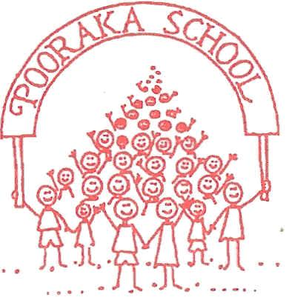

Pooraka Primary School Parent Code of Conduct and Communications Policy

Purpose

Pooraka Primary School provides a service for over 180 students and their families.
The purpose of this Communications Policy is to foster a safe, positive, and productive environment where respectful, clear, and effective conduct and communication supports the wellbeing of every student, support staff, teacher, leader and community member. This policy guides all members of the school community on how we communicate, ensuring that our interactions are built on the pillars of cooperation, respect, and shared responsibility.

Policy Statement

At Pooraka Primary School, we promote communication that is:
- Friendly and courteous
- Inclusive and respectful of diversity
- Collaborative and constructive
- Proactive and positive
- Timely and clear
Effective communication supports student learning, positive school culture, parental engagement, and partnership between home and school.

Guidelines for Communication

Cooperation in Communication:
- Be friendly, courteous, and approachable in all interactions.
- Participate in school life with positive intent.
- Access, read, and respond to school communications via apps and emails.
- Keep to timelines, appointments, and RSVPs, and respect time constraints.
- Respond positively and constructively to staff communications.
- Behave in a civilised and non-aggressive manner.
- Appropriate non-intimidating language
Respectful Communication:
- Support the school values and decision-making processes.
- Value diversity of opinion and listen to others, including their views.
- Communicate with a positive mindset and reinforce school pride.
- Value the privacy and time of all students, families, and staff.
- Show appropriate behaviour and language at all times.
- Encourage children to be responsible for their communication and behaviour.

Unacceptable Communication

Not showing respect includes:
- Gossiping or inappropriate comments, including on social media.
- Approaching other people’s children to discuss issues.
- Rudeness, sarcasm, aggressive demands, or put-downs to staff or other community members.
- Assumption that one perspective is always correct.
Not cooperating includes:
- Being aggressive, intimidating, or violent.
- Blaming or publicly criticising others.
- Being closed to different perspectives or feedback.
- Not supporting school policies, communication protocols, or procedures.

Responsibilities
- Staff will model and promote positive communication, respond to queries within reasonable timeframes (48 hours generally), and ensure information is shared clearly and regularly.
- Parents/carers are expected to engage respectfully, support school processes, and use appropriate channels for raising concerns or feedback.
- Students will be taught and encouraged to communicate respectfully and appropriately.

Breaches of This Policy

Breaches of this policy will be addressed in line with the Department for Education Policies and Processes. required

