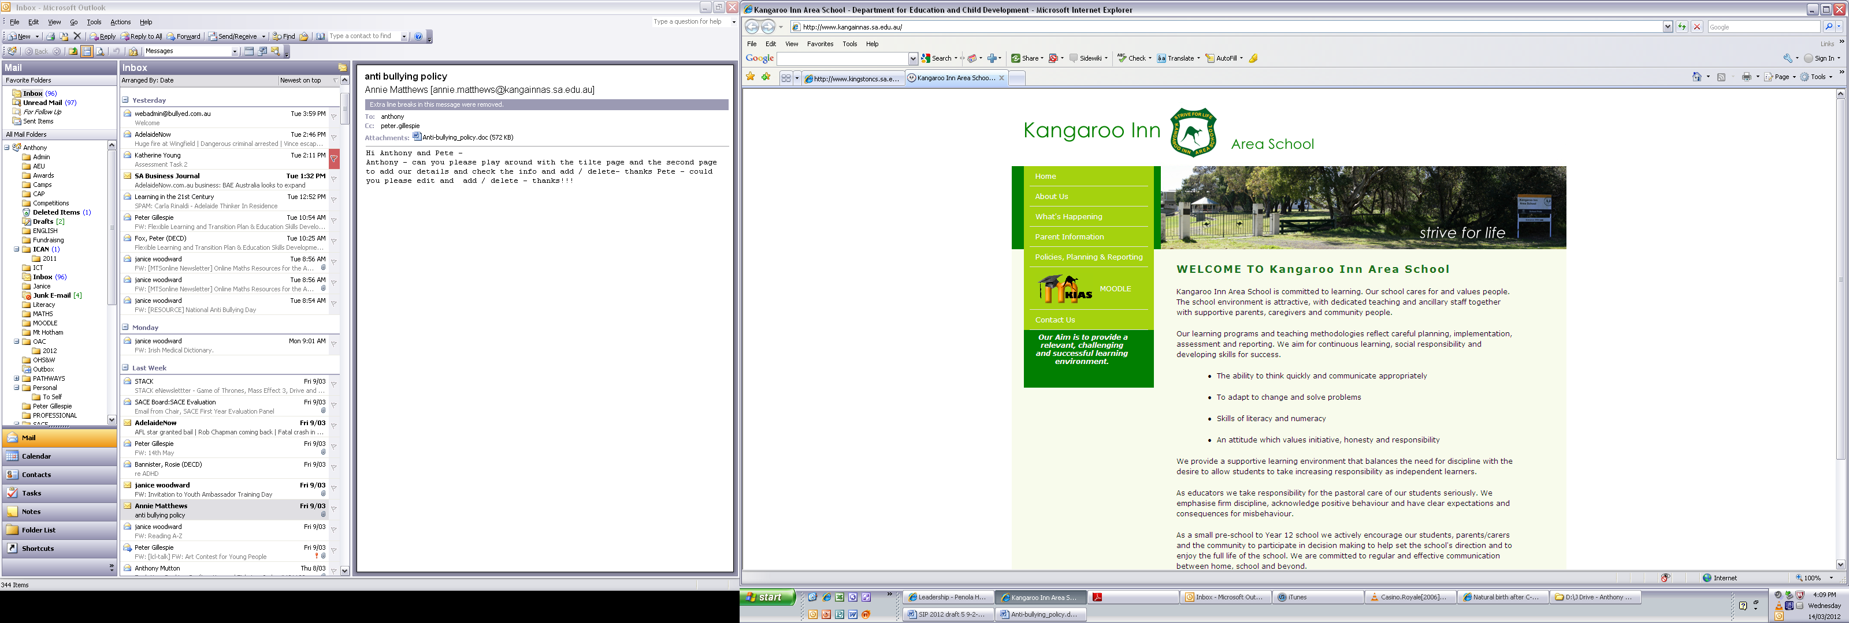



April 2025

KANGAROO INN AREA SCHOOL

Anti-bullying Policy



We believe that Kangaroo Inn Area School should be a safe place in which to work and learn where bullying will not be tolerated. We all have the right to be safe.
We believe -
- Everyone has the right to be treated as a worthwhile individual
- Staff and students have a right to operate in a bully free and harassment free environment
- Staff and students need a framework for dealing with bullying and harassment
- Our school community operates best when it is supportive, tolerant and respectful

Bullying has three main features

It involves a misuse of power in a relationship
Conflict or fights between equals are not defined as bullying. Bullying occurs where there is a power imbalance. This might come from:
- the context. For example a number of children acting against one child
- personal characteristics. For example different physical, emotional or social development.

It is ongoing and repeated
One incident of misbehaviour is not defined as bullying. Schools will respond to all incidents of misbehavior.
One act by a single person might be bullying if:
- the behaviour adds to a series of other people's behaviours that misuse power and result in harm
- it can be shared online or through technology to a wide audience, or repeated with multiple views.

It involves behaviours that can cause harm
Bullying can cause physical and psychological harm.
Physical harm can include injury. It can also include theft or damage to belongings.
Psychological harm can include:
- anxiety
- not wanting to go to school
- lack of interest in school
- isolation and depression.
Psychological harm can last some time. It will depend on a student's situation and the support available to them. Support might come from family, school and friends.
A fear of being bullied can create psychological harm.

Examples of types of bullying
Physical: hitting, kicking, tripping, pinching, pushing, damaging or stealing belongings, use of a weapon.
Sexual - any unwelcome written, verbal or physical contact of a sexual nature
Verbal or written: written or verbal abuse, name calling, insults, teasing, intimidation, threats, rumour spreading, unfair criticism, suggestive or misogynistic comments.
Social: social exclusion, lying, spreading rumours, unkind facial expressions or body language, mean and condescending looks, playing jokes to embarrass and humiliate, mimicking and damaging someone's reputation or social relationships.
Cyber: Cyberbullying is online bullying. It uses technology, including social media platforms. Verbal and social bullying can be cyberbullying when they occur online.
Cyberbullying includes:
  - abusive texts and emails
  - hurtful messages, videos and images, including images that have been changed
  - sharing personal images and videos without consent
  - pretending to be someone else online to be hurtful.
Graffiti - using pictures, tags or words
Group - forming groups to leave out, ignore or demonstrate disrespect
Indirect - influencing or organising someone else to bully or harass

Harassment, discrimination and violence
Bullying, harassment, discrimination and violence all create or add to a negative environment. This can make students feel unsafe and unable to reach their full potential.

Harassment
Harassment is behaviour that targets an individual or group. This can be because of their: identity, race, culture or ethnic origin; religion; physical characteristics; gender; sexual orientation; age or ability.
It offends, humiliates, intimidates or creates an unsafe environment. It might be a: pattern of behaviour or a single act. It might be on purpose or unintended.

Discrimination
Discrimination happens when people are treated differently to others. This can be because of their: identity, race, culture or ethnic origin; religion; physical characteristics; gender; sexual orientation; age or ability. Discrimination interferes with people's right to fair treatment and equal opportunities.

Violence
Violence is the intentional use of physical force or power. It can be threatened or actual, against another person. It might result in psychological harm, injury or in some cases death. It might involve provoked or unprovoked acts. It can be one incident, a random act or can happen over time.
Bullying, harassment, discrimination and violence may be based on gender, race, sexuality, culture, religion, disability and care status. Bullying, harassment, discrimination and violence for any reason is not acceptable in South Australian public schools. It will be responded to.
Responses will depend on the:
- behaviours
- needs of the students
- rights of all students to be safely included in learning.

Roles and responsibilities
We each have a role to play to:
- prevent bullying and harassment
- respond when it happens
- support those involved and affected by bullying.
The Australian Student Wellbeing Framework elements are leadership, inclusion, student voice, partnerships and support. They guide our practices and responses to prevent and reduce bullying in our school community.

School leaders and staff
- Model and promote positive behaviour. Value diversity, demonstrate respect, and include all students and their families.
- Provide and take part in professional development to build skills, knowledge and confidence about preventing bullying. Including how to recognise, respond and manage it.
- Assess bullying data and trends to develop prevention strategies.
- Collect data on bullying regularly. Use the data to plan how you will prevent and respond to bullying.
- Explicitly teach students about respectful relationships, bullying and cyberbullying. Teach them how to recognise bullying, what to do and how to get help.
- Work with students to come up with solutions to bullying. Include them in decisions that affect their safety and wellbeing.
- Support all students to be included, in particular students at higher risk of being bullied.
- Take action when bullying and cyberbullying has been reported. This includes incidents that happen out of school hours or off school grounds when it relates to school relationships.
- Report criminal matters to the South Australian Police.
- Help parents and carers to recognise bullying. Include information about what to do when their child is engaging in or affected by bullying.
- Work with families, service providers and the community to support students affected by bullying.
- Support students to repair and restore relationships that have been harmed by bullying.
- Have planned responses to bullying. Make them visible and consistent. Responses should foster trust and confidence.
- Help students to be physically and psychologically safe from bullying.

Parents and families
- Model and promote safe, respectful and inclusive behaviours.
- Help their children to be safe online at home. This includes checking their children's use of technology and social media.
- Make sure their children know how to identify and report bullying. Work with the school to help their children be safe from bullying.
- Talk to their children about safety issues. This includes bullying and cyberbullying. Help them understand what it is, why it is harmful and how to respond. Use the same messages the school uses.
- Report concerns about bullying to school staff.
- If a bullying incident happens, work with the school.
- Support their children to go to school while a bullying issue is being worked on.
- Get external professional support for their child, if needed.

Students
- Model behaviours that are safe, respectful and inclusive, both face-to-face and online.
- Build skills, knowledge and confidence to recognise, respond to and manage bullying.
- Be a part of decision making to improve student safety and wellbeing.
- Take a stand when bullying is observed. Step in, if it's safe. Seek help from adults.
- Support friends and peers get help from trusted adults if they experience bullying.
- Support friends to behave in safe, respectful and inclusive ways if their friends engage in bullying.

PREVENTION
The implementation of this Anti-Bullying policy will address any incidence of bullying at Kangaroo Inn Area School, provide a framework for action and explicitly state the responsibilities of all stakeholders in the school community. Prevention will include the following whole school strategies
- Be-You programs in the primary and secondary areas which will be integrated into class programs and operate as stand alone programs to address specific needs as they arise
- Implementation of the KIAS Values (see attached)
- Modelling respectful and inclusive relationships at all levels of schooling and in all circumstances
EARLY INTERVENTION
Students who are identified as being at risk of developing long-term difficulties with social relationships and those students who are identified at or after enrolment as having previously experienced bullying or engaged in bullying behaviour are initially monitored in class by the class teachers and the leadership team.
Concerns may be raised at Staff Meetings in the ‘Students At Risk’ segment or with the Coordinators / Principal where any of the following action could occur -
- Positive class intervention programs / strategies to support the student
- Part / whole staff intervention program is developed
- Parents / caregivers are notified
- Students are referred to support personnel located at the Department for Education (DfE) Limestone Coast Office

RESPONSE
Step 1 Informing
Kangaroo Inn Area School will ensure the school community has access to current information about bullying and develops an understanding about what constitutes bullying.
- NSW Education Department statement on Preventing and Responding to Bullying in Schools -2011 (see attached)
- Regular newsletter information
- Class programs and training and development
Step 2 Empowering
Kangaroo Inn Area School are implementing the following strategies to empower the whole school community to recognise and respond appropriately to bullying, harassment and victimisation, and behave as responsible bystanders
- DfE Cybersafety / Use Agreement (see attached)
- Brochures detailing processes are given to families and students
Step 3 Responding
Kangaroo Inn Area School will approach incidences of bullying with sensitivity and in a timely manner.
- The KIAS Grievance and Student Wellbeing policies detail the process for reporting and dealing with bullying incidences (see attached)
- Intervention strategies may include counselling for students who are bullied, who bully (applying consequences as necessary) and for bystanders, conferences & agreements to support safety & respect, assertiveness & conflict management skills, talking with parents/caregivers, suspension and reporting to police
- Parents will be informed of incidences involving their child by staff through a note or phone call
- Bullying incidences are recorded by staff and the Coordinators input the information onto the DFE – EMS where data can be collated on an annual basis to determine trends and address these as necessary
- Any incident involving threatening behaviour, violence or abuse will be reported to police as recommended by the DfE for students over 10 years of age
- Where child safety is a concern, staff may contact outside organisations
- Policies for Anti-bullying, Grievance and Student Wellbeing are reviewed and updated regularly, ratified yearly by the KIAS Governing Council and located on the school website
Step 4 Review
Kangaroo Inn Area School will seek feedback annually about the policy and it’s effectiveness through
- Annual DfE parent, staff and student surveys

ADDITIONAL INFORMATION
Limestone Coast Education Director Ph 87245300
Department of Child Development Parent Complaints Unit Ph 1800 677 435
Support Organisations
Child and Adolescent Mental Health Service (CAHMS)
Ph 87247055
Kids Help Line Ph 1800 55 1800
Parent Help Line Ph 1300 364 100
Families SA Ph 1800 800 747
Centrecare Ph 8724 9229

Support Websites
www.beyou.edu.au
www.bullyingnoway.com.au
www.cyberbullying.info
www.bullying.com.au
www.cybersafetysolutions.com.au
www.kidshelpline.com.au

SCHOOL CONTACT INFORMATION
Kangaroo Inn Area School
2329 Beachport-Penola Rd
Kangaroo Inn SA 5280
Ph 0887343046
Fax 0887343134
www.kangainnas.sa.edu.au

