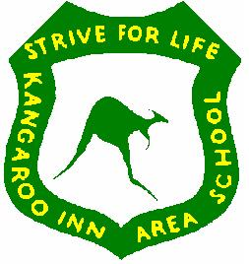  KANGAROO INN AREA SCHOOL | Uniform Policy  Ratified by Governing Council June 2025

KANGAROO INN AREA SCHOOL UNIFORM

All weather :
Gray or navy shorts, pants or trackpants
- Plain track pants/ shorts only – no logos
- Blue denim jeans acceptable – not ripped jeans
Green polo shirt with yellow stripe or sports shirt
Green jumper / Year 6 and Year 12 – Graduation jumpers
Dress - made in green check material
Plain navy vests and rain jackets may also be worn

Hats:
Wide-brimmed, legionnaires or bucket style hat during Terms 1 and 4.
Secondary students are able to wear caps. Beanies are acceptable in winter.

Footwear
Solid shoes or sandals.

Thongs, Ugg Boots and Plastic Sandals are Unacceptable.

Agriculture, Technical Studies, Home Economics and Science Lab. work - Students must wear closed shoes, and long hair tied back. Due to OHSW concerns, parents/caregivers will be contacted to bring in suitable footwear if students wear inappropriate footwear.

School uniforms are available for purchase from Since 56, George Street, Millicent and bucket hats are available from the front office.

