2025
Quality Improvement Plan for
Fraser Park Preschool

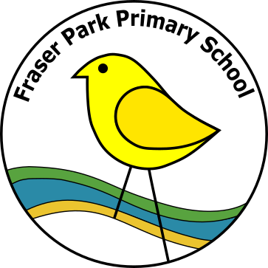

Site number:
Click or tap here to enter text.

Service name
Fraser Park Child Parent Centre

Service address
Click or tap here to enter text.

Service approval number
SE – 000103 60
Acknowledgment of Country
We acknowledge the Ngarrindjeri people as the traditional custodians of the lands and waters where our centre is located and recognise their continuing connection to country. We pay our respects to Elders past and present and extend that respect to all Aboriginal peoples.

Service context
Fraser Park Preschool is a school-based preschool. It is co-located within Fraser Park Primary School, a small category one site. A Learning Together family support service and the Edge student behaviour support program are also located at the site. The preschool and school are situated in the rural city of Murray Bridge, within the Murraylands area. The SEIFA index of disadvantage identifies Murray Bridge as one of the most disadvantaged communities in South Australia (Murray Bridge Council 2021-2022 annual report).

Many families of the children who attend Fraser Park Preschool experience stressors related to social, economic and educational disadvantage. The resources for learning within the community however, are rich. There is a diversity of home languages and cultures. There are long-standing connections with local schools, community volunteers and local Aboriginal organisations. The preschool is named Pulyeri. This refers to the blue wren, pulyeri watta (little bush bird) in the Ngarrindjeri language. Ngarrindjeri people are the Aboriginal custodians of the Murraylands area.

The preschool has a capacity of 15 children per session. Currently, five sessions per fortnight are offered to children. The days are Monday, Tuesday, and alternate Wednesdays. Preschool sessions begin at 8:50am and conclude at 3pm. The preschool is staffed by one teacher and one early childhood worker. Most children transition into the primary at the conclusion of their preschool year.

Statement of Philosophy
- We believe that children learn best through experiences in play that connect, acknowledge, and stretch their belonging, being and becoming as involved and motivated learners.
- We believe that a child’s identity as an active and purposeful learner is enhanced when educators work alongside and with the child. Educators are attuned to the pace and intent of the child's learning.
- We believe that strong partnerships with family and community will enhance our capacity to provide a learning environment where each child can flourish as a confident, creative and caring citizen.

Strengths
With reference to the three exceeding themes:
1. Practice is embedded in service operations
2. Practice is informed by critical reflection
3. Practice is shaped by meaningful engagement with families and/or the community
Quality Area 1: Educational Program and Practice
Approved learning framework
- At Pulyeri we use the EYLF V2 to inform our decisions when observing, analysing, planning, implementing and evaluating the learning and development of individual and groups of children.
- All topics in the Keeping Safe: Child Protection Curriculum are explored with children. Families are routinely informed. The concepts within the topics are integrated throughout our program in responsive and relevant ways during play, everyday routines and as we gather as a group.
Child centred
- Our formative assessment processes and conversations with children and families ensure that the program is child-centred, responsive to children’s thinking and explorations. Children’s current knowledge, strengths, ideas, culture, abilities and interests are the foundation of the program.
- All children have a personal learning plan that is designed and regularly reviewed with educators and family. The identified learning goals inform the cycle of planning- for individual children and for a group of children.
Program learning opportunities
- Preschool routines are intentional opportunities that strengthen our sense of learning as a community, caring for ourselves, our environment and each other.
Intentional teaching and critical reflection
- We critically reflect on the effectiveness of our intentional teaching actions to enhance learning by working alongside and with children in play, in everyday routines and as we gather as a group. We are intentional about the way the environment is set up to promote children’s deeper engagement with their play ideas.
Responsive teaching and scaffolding
- Quality verbal interactions are embedded in our ways of working. Educators slow down, engage at child’s eye level and ask open-ended questions from a place of genuine curiosity.
Child directed learning
- The program is enriched by individual and groups of childrens’ spontaneous curiosities as well as the big questions that children ask, often without words- such as “If I wait for a turn, will I miss out?”. Children’s wonderings are integral to the program.
Assessment and planning cycle and critical reflection
- We practice 15 minutes of focussed critical reflection on teaching and learning data at the end of each session. Our shared analysis of documentation informs the next cycle of planning. A systematic approach to formative assessment ensures that the learning progress of individual and group of children are enhanced by the program we offer.
Information for families
- Families are consulted and informed about their child’s learning progress through informal conversations with staff at drop off and pick up times. The routine around these important transition times was changed to facilitate this exchange. One educator is always free to listen and talk.
- Opportunities to design and review personal learning plans are scheduled in consultation with families. This may happen at a face-to-face meeting, by email or other digital means such as text messaging.

Strengths
With reference to the three exceeding themes:
1. Practice is embedded in service operations
2. Practice is informed by critical reflection
3. Practice is shaped by meaningful engagement with families and/or the community
Quality Area 2: Children’s Health and Safety
Wellbeing and comfort
- In Pulyeri we provide dedicated quiet areas for the children to have opportunities for rest. Relaxation, body awareness and times for quiet are part of everyday learning. Educators flexibly adjust the pace of the day to match our preschool and school community rhythms.
- Educators work respectfully in partnership with families to comfort and settle an upset child at times of separation as well as other sensitive matters such as toilet training.
- Breakfast, wellbeing lunches and fruit are offered to provide all children with comfort, care and social connection whilst at Pulyeri.
Health practices and procedures
- Staff engage in confidential and sensitive communication between health professionals and families to get the best outcomes for children. Health Support Plans are kept in the child’s record. This information is available for educators to inform planning that enhances children’s wellbeing for learning and development.
- The hand washing technique and reason why is explicitly taught to all children. The message is reinforced by posters above the taps and role modelled by educators.
- Sun protection concepts and routines are also explicitly taught and modelled by staff. The daily UV index determines if a hat is needed for outside play.
Healthy lifestyle
- Healthy eating, hydration and physical activity are important elements of the Pulyeri value of care- care for our bodies. Healthy eating is promoted in partnership with families and children through conversations as we share produce, recipes, cook and eat together.
- Children are routinely encouraged to take 5 sips of water at lunchtime, counting each sip in children’s home language, ie Dinka
Supervision
- The environment is set up each day with visibility and proximity for children’s safety in mind. A risk assessment is conducted with staff (and if relevant with children) when significant changes are made. Hazard inspections are conducted daily. Identified hazards are reported to principal for action.
- The educators work together to ensure that children are safe and that they have maximum access to quality educator to child/ren and child to child interactions.
- Emergency management
- Educators use the KS:CPC to explore the concepts of emergency, safe/unsafe with children. Evacuation and lockdown drills are practised with children once a term
Child protection
- All Pulyeri educators are trained in Responding to Abuse and Neglect and the teaching educators are trained in Child Protection Curriculum.

Strengths
With reference to the three exceeding themes:
1. Practice is embedded in service operations
2. Practice is informed by critical reflection
3. Practice is shaped by meaningful engagement with families and/or the community
Quality Area 3: Physical Environment
Fit for purpose
- Our outdoor and indoor spaces offer a safe environment for children to take risks and engage with learning experiences. We have a large amount of space for providing a variety of explorative and sensory experiences utilising natural and man-made products. There are large, shaded areas, soft fall areas, gardens and sand and mud pits.
- The expansive lawn area provides a calm, cool and welcoming effect. It also minimises the impact of airborne dust which may trigger an asthmatic episode for some children.
Upkeep
- The equipment used in Pulyeri is developmentally appropriate, regularly maintained and updated. All equipment and resources are clean and stored in for easy access storage. Daily risk analysis occurs and equipment that is damaged is removed for repair or disposal.
Inclusive environment
- We ensure adequate amounts of equipment and furniture are available for the children and quiet areas are also accessible. The facilities utilise natural light and ventilation.
- The building and yard are wheelchair accessible, and shelving is accessible for children to retrieve a wide range of learning resources
- Children’s home languages and heritages are reflected in the preschool environment in ways that families are happy to share
Resources support play-based learning
- Children have opportunities to play with and on natural elements within Pulyeri.
- Open ended learning experiences are always available for children
- Families actively contribute to the preschool’s resources for play through support of children’s fundraising events and through donations. Families share their resources with each other such as clothes and toys
Environmentally responsible
- We prioritise the purchase of natural, sustainable materials where possible. Appropriate materials from op-shops are re-purposed for play eg, cooking utensils for the sand pit and mud kitchen, size 000 baby clothes for our dolls.
- Children experience for themselves the importance of water conservation as they must work the pump connected to the rainwater tank to fill their containers.

Strengths
With reference to the three exceeding themes:
1. Practice is embedded in service operations
2. Practice is informed by critical reflection
3. Practice is shaped by meaningful engagement with families and/or the community
Quality Area 4: Staffing Arrangements
Organisation of educators
- Staffing ratios are maintained at all times
- Due to a significant number of Aboriginal children there is a focus on employing Aboriginal educators, to support our families and children’s engagement with learning. The preschool teacher and ECW are Aboriginal women.
- Timetable is managed to best maximise time between preschool staff, leadership and R/1 teacher.
Continuity of staff
- We maintain consistency of educators.
Professional collaboration
- Fortnightly staff meetings are run by the Educational leader, attended by Pulyeri educators and the Reception/1 teacher, and offered to volunteers and practicum students to attend, giving opportunities for collaboration in the planning and assessment cycles.
- Professional collaboration around children’s transitions into school are planned throughout the year. They are intentional and purposeful to build strong relationships between children, teachers and their family. The preschool and school work in partnership with families to enhance children’s continuity of learning
Professional standards
- All teachers in Pulyeri are Early Years trained. All School Support Officers and Early Childhood Workers working with the preschool children have obtained or are enrolled in courses to obtain a minimum qualification of Certificate 3 in Children’s Services.
- All educators are trained in Department for Education approved 1st aid training and Responding to Abuse and Neglect training. Each educator participates in Performance Management meetings.
- Training and Development is promoted to educators and encouraged. Educators, volunteers and practicum students are expected to adhere to the Code of Ethics for the South Australian Public Sector of which they are made aware upon induction. Volunteers and practicum students upon induction are given a Volunteer Agreement to sign before commencing at Pulyeri.

Strengths
With reference to the three exceeding themes:
1. Practice is embedded in service operations
2. Practice is informed by critical reflection
3. Practice is shaped by meaningful engagement with families and/or the community
Quality Area 5: Relationships with Children
Positive educator to child interactions
- Photo displays, newsletters, and work sample displays and books are used to value children’s work and develop relationships. Children and families love to see images of themselves around the preschool environment, sparking deep conversations about identity and learning. Families of Aboriginal children gave feedback that this is a preferred way to talk about their child’s learning progress.
Effective strategies that were embedded in 2024 to promote positive educator-child-child interactions will continue-
-Tune in to children… actively listen and be available to provide comfort/affirmation as needed
- Notice and name pro-social behaviours in the moment
- Link up … highlight the ideas of one child for other children to notice
-Model positive self-talk to support emotional regulation in times of stress
Dignity and rights of the child
- Our values and dispositions guide the way that we interact with children and the way that we support children to interact with each other. The Marte Meo strategy where educators act and speak in ways that are “not bigger than the child”, supports a sense of calm and safety for all children
- The KS:CPC topic of body awareness and privacy is discussed with children- their voices inform how the bathroom and nappy change area is shared to look after everyone’s dignity.
- Educators let children know what will happen, name up our actions and intentions. Educators model how to ask for and give consent.
Collaborative learning
- Side-by-side opportunities to learn are always set up
- Marte Meo technique of lifting up social information promoted children’s awareness of themselves and other people as a person with good ideas to share
- Cooperation is modelled and highly scaffolded by educators
Self-regulation
- Educators co-regulate with children. We don’t assume that a child is developmentally ready to self-regulate. We work alongside and with children to name the feelings that can sometimes overwhelm children. We tune in to bodily cues, listen first and check in with children to confirm or affirm their emotional state.
- We are intentional about first building a relationship of trust with each child for them to be comfortable with co-regulation. This may look like scheduling 1:1 time focused on an activity the child enjoys.

Strengths
With reference to the three exceeding themes:
1. Practice is embedded in service operations
2. Practice is informed by critical reflection
3. Practice is shaped by meaningful engagement with families and/or the community
Quality Area 6: Collaborative Partnerships with Families and Communities
Engagement with the service
- We foster a collaborative connection to our community and promote inclusive practice. Upon enrolment each family is given an enrolment pack that consists of comprehensive information about our service. Families are offered a tour of Pulyeri as well so that questions can be addressed in context.
- Communication between home and preschool is preferred by our families via a short text and a follow up phone call or face-to-face conversation. A daily notice board is also a good way to provide information about the program.
- Each child’s learning goal and progress is informed by intentional, scheduled conversations with families. Children’s learning journals are placed near the information pockets for easy access by children and families to spark learning conversations.
- At the beginning of each year families are encouraged to be a part of the Fraser Park Governing Council. The minutes and reports from these meetings are available upon request. Families have opportunities to read about what we are doing in the preschool via newsletters, the preschool program boards and by looking at the displays of work and photos around the preschool.
- A Learning Together playgroup operates on Friday afternoons. This presents families from the community to find out about the service at Pulyeri and to access information about resources for their child’s learning and development.
- Pulyeri hosts a community Twilight Playgroup event twice a year in partnership with Learning Together and Tinyeri Children’s Centre. This is open to all families in Murray Bridge
- The program is enhanced by our partnership with Murundi Aboriginal Health Service and the Murraylands Landscape Board. The children’s learning is also enriched by excursions to access local services such as Kindergym and businesses such as River City Pets.
Transitions
- The transition from home to preschool is supported by unlocking the gates at 8.30am. This gives families the opportunity to help their child settle into the day. It allows informal conversations to occur between educators and families. Families and children can help with routine tasks like putting up the swings, getting out the playdough, putting child’s lunch in the fridge,

Strengths
With reference to the three exceeding themes:
1. Practice is embedded in service operations
2. Practice is informed by critical reflection
3. Practice is shaped by meaningful engagement with families and/or the community
Quality Area 7: Governance and Leadership
Service philosophy and purpose
Our site has developed a statement of Philosophy that has been passed by the Governing Council.
Management systems
Our site is governed by a Governing Council, consisting of Fraser Park community and wider community members. We also hold regular educators meetings-ensuring all preschool educators are informed and have opportunities to air opinions. All adults and volunteers working in our site have a current Criminal History Check, a copy of these are kept in educators records in the Front Office.

Roles and responsibilities
Continuity of educators, be it regular or relieving is essential for the smooth running of the preschool. The preschool program is facilitated by a qualified Early Years Teacher.
Continuous improvement
Our Quality Improvement Plan has been created in collaboration with educators, families, children and our community.

Educational leadership
Educators performance is evaluated and facilitated by attending regular performance management meetings with the site leader
Development of professionals
Preschool teaching educators have undergone training in RRR. All confidential records are stored in a locked filing cabinet.
Grievances and critical incidences are dealt with according to Department for Education regulations.

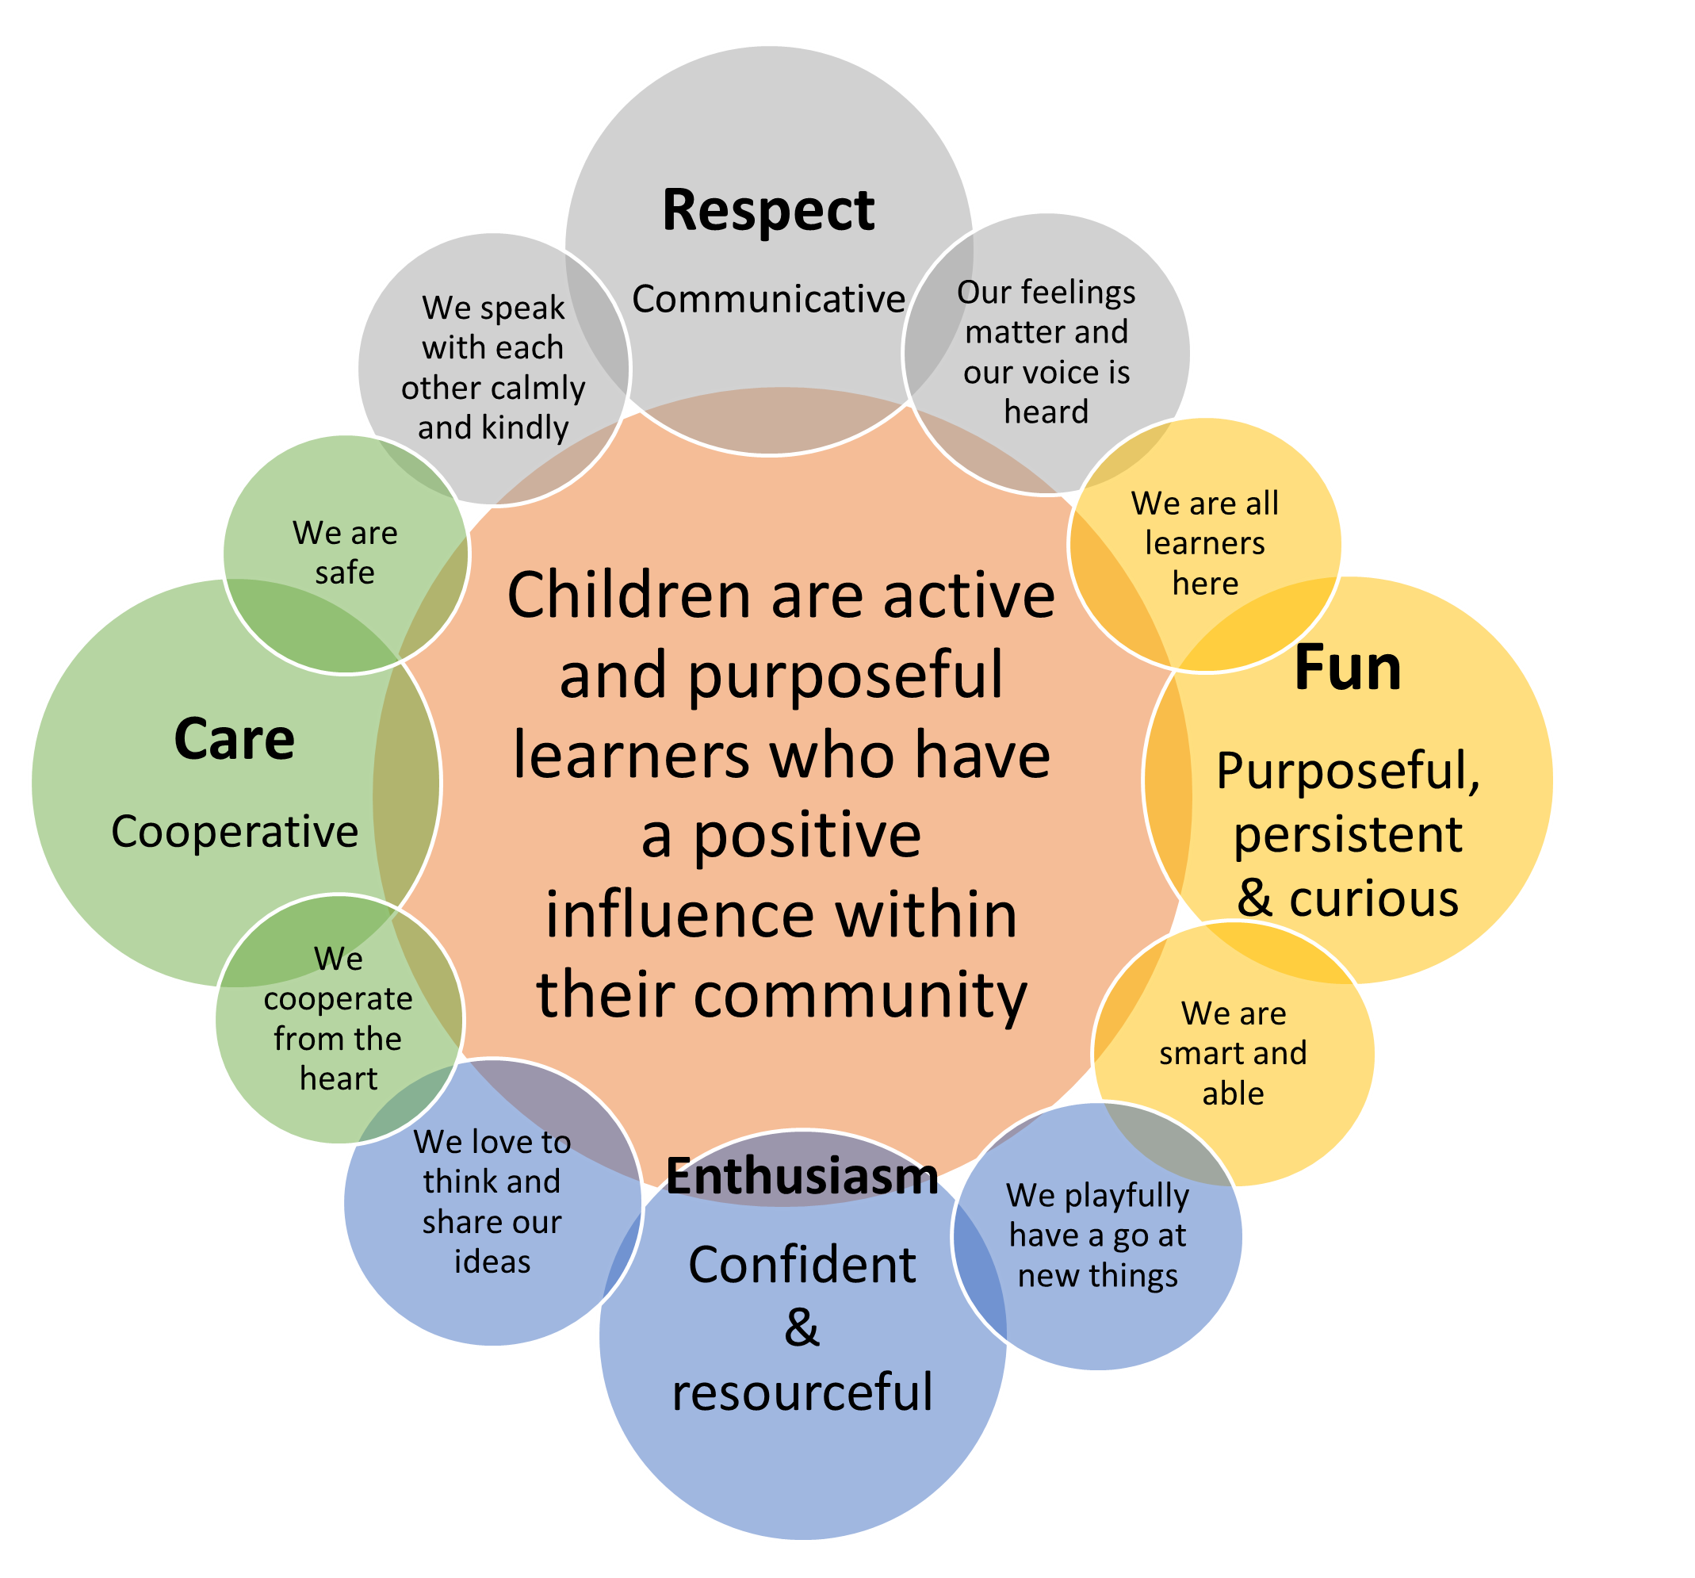
Respect. Care, Enthusiasm and Fun are Fraser Park School values.

These values guide the way we recognize, support, and plan to enhance each child’s dispositions for learning at Pulyeri preschool and playgroup.

This diagram shows how our values and dispositions for learning are expressed and embedded in the culture of Pulyeri preschool and playgroup.

They will support us to make visible children’s agency as learners in 2025.

Learning Improvement Plan 2025
Critical reflection on our learning in 2024-
Our analysis of teaching and learning in 2024 indicated that the co-regulation strategies used by educators effectively supported the development of all children’s collaborative play and language skills. We will continue to embed co-regulation strategies in 2025.
Our work with David Gilkes on pedagogical documentation caused us to reflect deeply on how we engaged children as active agents in their learning. Our teaching and learning theory for 2025 is that if we intentionally partner with children to engage their thinking about themselves as independent and interdependent learners, then children would become more purposeful and aware of their agency.
The goal that we arrived at for children also aligned with the strategic area for improvement identified in the 2025 Site Learning Plan for Fraser Park School, which is Learner Agency
The learning that we are going after in 2025-
We want children to know that they are active and purposeful learners who have a positive influence within their community
Success criteria – what we might see children know, do, understand and feel
Through analysis of our pedagogical documentation children will increasingly:
- tune in to ways to be resilient and persistent such as take a risk to try new or unfamiliar experiences
- talk about and document their learning as thinking, feelings and actions with educators and peers
- say things like “mistakes make my brain grow”, “practise makes my brain grow”
- use words and images to identify strengths for learning in themselves and others, ie creative, brave, persistent, confident
- exchange ideas, feelings and understandings using language and multiple representations in play … talk about ideas as being in our head but we can show it to others
- notice and respond positively to the ideas of others … smile at each other, copy each other, share materials with each other, cheer each other for having a go
- Work together to complete a joint project over time … something of keen interest to them as a whole community

Leadership actions:
If we work collaboratively across Fraser Park School and Fraser Park Preschool to integrate the strategic action for improvement of Learner Agency, then we will see children and students increase their engagement and achievement in learning.

Actions | NQS links | Timeline | Roles & responsibilities | Resources
- Align PQIP with 2025 Site Learning Plan regarding the strategic action of Learner Agency  - Review PQIP draft with preschool team members  - Send final PQIP to Governing Council for ratification and send to ACECQA  - Review and update policy and procedures folder- include child agency where appropriate eg- Behaviour Management procedure to reflect philosophy statement  - Monitor and support the development and implementation of the educational program and assessment and planning cycle  - Provide professional learning to support educators co-regulation and inquiry learning skills – personal PDP goals | 77.2.1 &2  Continuous improvement and educational leadership  7.2.3  Development of professionals | Term 1, Week 0  T1, Week 4  T1, Wednesday W1 & W3  Termly | Claire and Lauren to prepare a draft of PQIP 2025  Ajith and Michael to discuss and contribute feedback to PQIP  Kimberly to review and ratify PQIP  Claire and Lauren  Kimberly  C & L will provide pedagogical documentation in timely way and meet with leader to critically analyse progress.  Kimberly | PQIP draft 1  SLP 2025  NQS handbook  DfE policies and procedures  DfE Preschool Curriculum Resources- Emotional Domain  Social Domain

Educator actions, Our challenge of practice:
If we intentionally partner with children in talking about, documenting, and applying their ideas, then children will experience themselves as active agents of their own and others’ learning.

Actions | NQS links | Timeline | Roles & responsibilities | Resources
- Notice, name and celebrate what children know, can do, feel and understand about being resilient and persistent. For example, ‘I love how persistent you were when you were writing your name. Even though it was hard, you didn’t give up. You did it!  - Link up … highlight the ideas of one child for other children to notice  - Model positive self-talk to support emotional regulation in times of stress  - Explicitly model the language of positive interactions in play | 1.2.2  Responsive teaching and scaffolding  5.1.1  Positive educator to child interactions  5.2.1  Collaborative learning  5.2.2  Self-regulation | Week 0 |  | Marte Meo strategies  Social Domain  Emotional Domain  Well-being science  Developing early maths through story

Learning environment as the ‘third teacher’
Routines, resources and spatial organisation set up to enhance children’s agency as learners
Click or tap here to enter text.
Actions | NQS links | Timeline | Roles & responsibilities | Resources
- Educational leader to plan with SSOs so that lunchtime is a learning time for children.  - Resources support play-based learning and personal discovery.  - The inside and outside spaces invite care, respect and promote collaborative play. | 2.1.1 | Week 0

Partnership with family and community
Effective partnerships with families support children’s access, inclusion and participation in the program. Family and community expertise, culture and values are respected and inform decisions about children’s learning
Actions | NQS links | Timeline | Roles & responsibilities | Resources
- Educators will structure the day to maximise opportunity for 1:1 conversation with families | 6.2.2  6.1.2 | Week 0

Goal 1: for children to know that they are active and purposeful learners who have a positive influence within their community
Review and Evaluate - Have we achieved our improvement goal? What have we learned and what are our next steps?
What progress have we made? Have we achieved our goal?
Click or tap here to enter text.

Enablers: What factors have been critical for success?
Click or tap here to enter text.

Inhibitors: What factors have impeded progress? How will we work through this?
Click or tap here to enter text.

Recommendations: What are the next steps to take?
Click or tap here to enter text.

Review and Evaluate - Have we achieved our NQS priorities? What have we learned and what are our next steps?
What progress have we made? Have we achieved our priorities?
Click or tap here to enter text.

Enablers: What factors have been critical for success?
Click or tap here to enter text.

Inhibitors: What factors have impeded progress? How will we work through this?
Click or tap here to enter text.

Recommendations: What are the next steps to take?
Click or tap here to enter text.

Endorsements
Endorsed by director/principal
Name
Click or tap here to enter text.

Date
Click or tap to enter a date.

Signature:

Endorsed by governing council chairperson
Name
Click or tap here to enter text.

Date
Click or tap to enter a date.

Signature:

Endorsed by education director

Name
Click or tap here to enter text.

Date
Click or tap to enter a date.


Signature:

