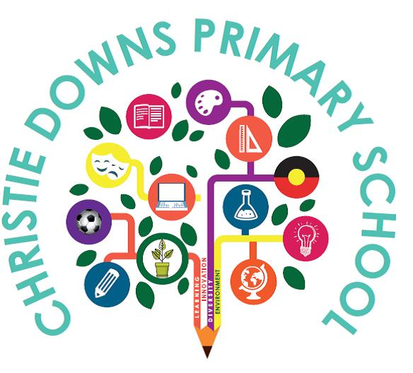

BEHAVIOUR SUPPORT POLICY
Christie Downs Primary School is an inclusive school where Educators work together to provide quality learning outcomes for each individual child in an integrated and inclusive environment. Everyone is supported to understand the concept of responsible behaviour.

Positive working relationships between all members of the community are based on mutual respect, trust, honesty, commitment, open communication,
co-operation, collaboration and equality.

Our philosophy is to foster an
inclusive teaching and learning environment that challenges students
to reach their potential through high
expectations and meaningful relationships

Student engagement, regular attendance and positive behaviours will be supported through the Berry Street Education Model, Interoception and relationship based whole-school classroom practices. Including targeted and individualised support when required.

Strategies and interventions to support student’s positive behaviour development reflect the department’s goal of safe inclusion for all students.

Scope
Christie Downs Primary School’s Behaviour Support Policy guides:
- the behaviour we expect of children and young people
- how staff, parents and carers will support positive behaviour
- the safe inclusion of children and young people.

Christie Downs Primary School’s Behaviour Support Policy aligns with:
- the Department for Education behaviour support policy.

About behaviours
Children and young people’s behaviours fall along a continuum. This means behaviour can range from safe to unsafe.

Range of behaviours
- Positive, inclusive and respectful behaviours.
- Low level, developmentally appropriate boundary testing. This behaviour can interrupt learning but is usually simple to redirect and minimise through universal behaviour support strategies for all children and young people.
- Challenging behaviours that cause concern due to their severity, frequency or duration. This behaviour can significantly interrupt learning and needs consistent guidance and support to minimise. Targeted interventions are provided for those children and young people who need extra support.
- Complex and unsafe behaviour that is severe, frequent, lasts a long time or is unsafe for the child or young person or those around them. These behaviours require intensive and individualised interventions.

All along the continuum, the policy and practice approaches are proactive, consistent, responsive and tailored to the child or young person’s needs.

How we implement the department’s behaviour support policy
We will support the safe inclusion of children and young people in learning with these actions.

Teach
We will explicitly teach positive behaviour and expectations about behaviour.
Our actions
- Create predictable structures and routines in the learning environment. This guides children and young people in how to positively participate in learning.
- Teach children and young people self-awareness, self-management, social awareness and social management.

Intervene
We will intervene to prevent, reduce or redirect behaviours of concern. We will use methods that are the least exclusionary possible.

Our actions
- Staff use proactive strategies to co-regulate children and young people to prevent behaviours of concern.
- Regulation or calming spaces are provided for children and young people to use as needed. These spaces are supervised by an Educator who supports children and young people to de-escalate until they feel safe, calm and ready to return to their learning environment.

Work with others
We will work with children, their families, professionals and other key adults to understand the environmental, social and family context of a child or young person’s behaviour. We will draw on these people to support positive behaviour change.
Our actions
- Value children and young people’s perspectives. Seek their ideas when developing behaviour supports.
- Engage children, young people and families to understand possible reasons for behaviour.
- Use case management and Team Around the Child approaches to coordinate, assess, plan, monitor and review behaviour interventions.

Respond
We will provide visible, fair and equitable behaviour responses that foster confidence and trust.
Our actions
- Tell those who raise behaviour concerns about the process for responding to the behaviour, without disclosing personal information of the parties involved.
- Collect information about behaviour incidents to assess the behaviour and the response required.
- Understand the experience of the incident for those involved.
- Tell parents and carers of those involved in or affected by the behaviour, unless there are significant reasons not to, for example, safety concerns.
- Apply evidence-based behaviour responses tailored to the individual needs of children and young people.
- Support the inclusion of children with disability, children in care and Aboriginal children who are at higher risk of exclusionary responses to their behaviours.
- Document planned behaviour support responses in personalised plans, for example, One Plan, behaviour support plan, safety and risk management plan, and support and safety plan.

- Repair and restore relationships
- We will repair and restore relationships harmed by behaviours of concern when we have assessed that it is emotionally and physically safe and in the best interests of everyone involved.
Our actions
- Children and young people who have behaved inappropriately are supported to recognise the impact of their actions, repair the harm caused and restore relationships when appropriate, safe and consented to by all parties.
- Implement restorative approaches to prevent, reduce and respond to behaviours of concern.

Create safety and wellbeing
We will create safety and wellbeing for people involved in behaviour incidents.
Our actions
- Use strategies to reduce the risk of harm to children, young people and staff following behaviour incidents.
- Only use suspensions and exclusions as a last resort and where other interventions to create safety have been exhausted or are unavailable.
- Refer children, young people, staff and others who have been harmed by unsafe behaviours to counselling or other support.
- Engage department supports when responding to serious incidents. For example, the Social Work Incident Support Service, (SWISS).

Behaviours of concern
Behaviours of concern:
- are challenging, complex or unsafe
- are serious or frequent or last a long time
- can significantly interrupt learning for the child, young person or others
- could put the child, young person or others in danger
- need consistent guidance and support.

Behaviours that disrupt learning or threaten safety will always receive a response that considers:
- the needs of the child or young person with behaviours of concern
- other people’s rights to learning and safety.

How we respond to behaviours of concern
At Christie Downs Primary School, we use specific responses to behaviours of concern.
Educator responses
- Use differentiated instruction to teach and reteach the behaviour expectations and required skills. Using varied approaches to what and how students learn, to meet all students’ needs.

- Partner with students, parents, carers and others to create plans that support positive behaviour change.
- Explicitly teach interoception skills. Support students to learn to self-regulate using an interoception space, interoception activities, or both.
- Provide time and space for students to self-regulate or co-regulate with appropriate support and supervision. This might include sitting quietly, talking quietly, doing calming activities (for example breathing or yoga) or physical activity (for example running, shooting hoops or bouncing a ball).
- Interrupt behaviours of concern. Name and describe behaviours to help students understand what they are doing that is problematic. Redirect students to the preferred behaviour. Support students to develop and practice the skills required to maintain the preferred behaviour.
- Offer students choices that allow them to stay regulated and participate. For example, giving them the choice to finish their work now or at another specified time or to do their work sitting down or standing up.
- Use natural consequences related to the behaviour. For example, if the student made a mess, they help to tidy up at recess before going outside to play.

Leader responses
- Monitor behaviour. Act on reports about behaviours of concern. This includes incidents that happen out of hours or off-site where there is a reasonable connection between the behaviour and Christie Downs Primary School.
- Consider suspension and exclusion only as a last resort, and where other interventions to create safety have been exhausted or are unavailable.
- Report criminal offences to the Police.
- Work with the Education Director and Department for Education staff to plan whole of site communications about serious behaviour incidents.

- Provide leadership and/or external assistance to facilitate restorative processes (including in reconnection meetings) when support is required to repair the harm caused and restore relationships.

Department level responses
- The Education Director will assist the Principal if a suitable school placement cannot be arranged for a student who has been excluded as a strategy of last resort to support safety.
- Department staff support schools and Local Education Teams to respond to behaviour incidents.

Responsibilities

Children and young people
- Treat others with kindness and respect.
- Make sure their behaviour is safe, respectful and inclusive. This includes verbal, physical and online behaviour.
- Seek help from adults to intervene when they see behaviours of concern in person or online.
- Support their friends and peers to seek help from trusted adults when their friends are experiencing behaviours of concern.
- Support their friends to behave in safe, respectful and inclusive ways.
- Report behaviours of concern to an educator.

Parents and carers
- Report any child or young person’s concerning or unsafe behaviour to an Educator, Student Wellbeing Leader, Senior Leader or Principal.
- If an incident happens, work collaboratively with us to resolve the concerns.
- Follow the complaint resolution process to deal with concerns. A copy of the complaint resolution process is on our website or in our front office.
- Show and encourage safe, respectful and inclusive relationships with:
  - their own children
  - other children and young people
  - other parents and carers
  - staff.
- Support their children to develop safe behaviours at home. Check on and supervise their children’s social interactions, including online.
- Seek support from our staff to create consistent responses to behaviours of concern. This includes at home and at our site.

- Know about our behaviour support policy. Know how to identify and report behaviours that are concerning or unsafe.
- Talk to their children about safety issues, including unsafe behaviours. Help them understand what it is, why it’s harmful and how to respond. Use the same messages that Christie Downs Primary School promotes.
- Make sure their children keep coming to our site while a behaviour issue is being resolved. This is in a child or young person’s best interest. If concerned that their child coming to our site is not in their best interest, talk to us.
- Seek external professional support for their children when needed.
- Do not approach other children or parents about behaviours of concern. Report this to us for follow up.
- Understand that, because of confidentiality, we cannot share information about other children.
- Support their children to stay off-site during suspension, exclusion or expulsion. A child can still come on-site if they have the leader’s written approval.

Date: November 25 Review Date: November 2026

