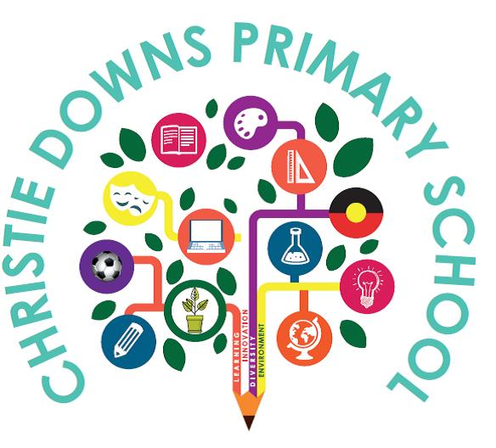

BULLYING PREVENTION POLICY
Our school’s vision of Dream Believe, Achieve and our school’s values of Respect, Responsibility and Teamwork, respond to the aspirations of our community and design our learning.
We aim to nurture a community where individual differences are appreciated, understood and accepted.
Our Bullying Prevention Policy reflects this context.

RATIONALE
At Christie Downs Primary School, we strive to nurture a safe and inclusive learning environment where all learners feel they belong through connections with their peers, educators, community, and curriculum. We strive to inspire learners to be responsible and informed citizens who understand their own rights and actively take responsibility to uphold the rights of others.
SCOPE
The Bullying Prevention Policy applies to all learners, educators and families at Christie Downs Primary School.

DEFINITION OF BULLYING
A national definition of bullying has been endorsed by the Education Council.
Bullying is an ongoing and deliberate misuse of power in relationships through repeated verbal, physical and/or social behaviour that intends to cause physical, social and/or psychological harm. It can involve an individual or a group misusing their power, or perceived power, over one or more persons who feel unable to stop it from happening.
Bullying can happen in person or online, via various digital platforms and devices, and it can be obvious (overt) or hidden (covert). Bullying behaviour is repeated, or has the potential to be repeated, over time (for example, through sharing of digital records.
Bullying of any form or for any reason can have immediate, medium, and long-term effects on those involved, including bystanders.
Single incidents and conflict or fights between equals, whether in person or online, are not defined as bullying.
What bullying is not
- Single episodes of social rejection or dislike.
- Single episode acts of nastiness or spite.
- Random acts of aggression or intimidation.
- Mutual arguments, disagreements, or fights.
These actions can cause great distress: however, they do not fit the definition of bullying. Bullying involves deliberate and repeated incidents.

BULLYING HAS THREE MAIN ELEMENTS
It has a misuse of power in a relationship
Conflict or fights between equals are not defined as bullying. Bullying occurs when there is a power imbalance. This might come from:
- The context. For example, several children acting against one child.
- Personal characteristics. For example, different physical, emotional or social development.

It is ongoing and repeated
One incident of misbehaviour is not defined as bullying. We will respond to all incidents of misbehaviour.
One act by a single person might be bullying if:
- The behaviour adds to a series of other peoples’ behaviour over misuse power and results in harm.
- It can be shared online or through technology to a wider audience, or repeated with multiple views.
It involves behaviours that can cause harm
Bullying can cause physical and psychological harm. Physical harm can include injury. It can also include theft or damage of belongings.
Psychological harm can include:
- Anxiety.
- Not wanting to go to school.
- Lack of interest in school.
- Isolation and depression.
A fear of being bullied can create psychological harm. Psychological harm can last quite some time. It will depend on a learner’s situation and the support available to them. Support might come for our school, family or friends, or an external provider.

HARASSMENT, DISCRIMINATION AND VIOLENCE
Harassment
Harassment is behaviour that targets an individual or group due to their:
- Identity, race, culture, or ethnic origin.
- Religion.
- Physical characteristics.
- Gender.
- Sexual orientation.
- Ability or disability.

Harassment can offend, humiliate, intimidate, or create a hostile environment. It may be:

- An ongoing behaviour or a single act.
- Directed randomly or towards the same person(s)
- Intentional or unintentional.

DISCRIMINATION
Discrimination occurs when people are treated less favourably than others because of their:
- Identity, race, culture, or ethnic origin.
- Religion.
- Physical characteristics
- Gender.
- Sexual orientation.
- Ability or disability.

VIOLENCE
Violence is the intentional use of physical force or power, threatened or actual, against another person(s) that results in psychological harm, injury or in some cases death. It may involve provoked or unprovoked acts and can be a single incident, a random act or can occur over time.

PROMOTING POSITIVE BEHAVIOUR
As a school we will:
- Maintain a safe learning environment.
- Commit to the Berry Street Education Model across site.
- Promote positive and productive behaviour that demonstrates value for diversity, respect, and inclusion for all learners, educators, and families.
- Acknowledge and support everyone’s rights and responsibilities toward creating connection and belonging in the learning environment.
- Ensure definitions of bullying are known and understood by educators, learners, and our community. Via assemblies, circle time in classrooms and posters around the school.
- Ensure consistent and developmentally appropriate behavioural expectations are across site.
- Use consistent language among educators, families, learners, and the broader community to encourage positive behaviours and social interactions.
- Ensure bullying is easily reportable and that learners feel confident to seek support and raise concerns.
- Build staff skills, knowledge and confidence to prevent and respond to bullying, including cyberbullying. Restore safety after critical incidents.
- Ensure information about the complaints process is available.
- Student Wellbeing Leader will collect bullying data regularly, analyse data and trends to plan how we will modify our bullying prevention strategies and responses as necessary, with Governing Council, learners, and families.
- Develop solutions to bullying with learners, including them in decisions that affect their safety and wellbeing.
- Act when bullying and cyberbullying are reported.
- Report criminal matters to SAPOL.
- Work with families, service providers and community to support learners affected by bullying.
- Have planned responses to bullying that are consistent, and foster trust and confidence.
PREVENTION STRATEGIES

EDUCATOR RESPONSIBILITIES
Educators will:
- Actively teach and model safe and inclusive behaviours, through the Berry Street Education Model and The Keeping Safe: Child Protection Curriculum.
- Develop and maintain supportive relationships and communicate effectively with learners and their families.
- Assist learners to understand bullying, including cyberbullying, prevention, identification, response and reporting across all year levels.
- Teach positive behaviours and social emotional skills.
- Support Wellbeing Surveys throughout the year.
- Access Interoception Room for students where appropriate
- Interest based Clubs are available for learners to access during break times to provide safe, supervised activities for learners.
- Intervene in incidents of bullying or observed bullying behaviour.
- Take all reports of bullying seriously and follow up concerns immediately with fair and consistent responses to incidents or suspicions.
- Document all bullying incidents on Yellow Slips or directly onto EMS.
- Reviewing outdoor learning duty procedures and Positive Behaviour Policy.
- Implement restoratives to follow up with learners when bullying incidents have been resolved, including both victim, perpetrator, and observers where possible.
- Providing professional learning for educators in collaboration with local agencies.
LEARNER REPSONSIBILITIES
Learners will:
- Behave in safe, respectful, and inclusive ways that reflect and promote our school values and vision.
- Understand the types and definitions of bullying.
- Treat others with kindness and support peers to behave in safe, respectful, and inclusive ways.
- Report any concerns or bullying behaviour to a trusted adult.
- Take part in decision making to improve learner safety and wellbeing.
FAMILY RESPONSIBILITIES
As their child’s first and ongoing educators, families shape and support their child’s positive experience at our school by:
- Promoting pride in our school and maintaining positive connections with educators.
- Understanding that behaviour is developmental and provides a learning opportunity.
- Working collaboratively with our school to resolve any concerns about behaviour when incidents occur.
- Helping their child to be safe online at home. This includes monitoring their child’s use of technology and social media.
- Making sure their child knows how to identify and report bullying.
- Understanding our school is required to maintain confidentiality for all learners and will not be able to report an outcome in relation to another learner.
- Reporting bullying incidents to our school.
- Supporting their child to attend school while a bullying issue is being resolved.

RESPONDING TO BULLYING

At Christie Downs Primary School we respond promptly and effectively to issues of bullying.
A range of consequences may be used for learners who bully or harass, including:
- Time spent out of the classroom or outdoor learning time.
- Implementation of an individualised play program.
- The Principal can suspend and/or exclude learners from school.
- Police may also need to be contacted if the behaviour is considered illegal.

Bullying is an ongoing and pervasive behaviour that is found in all aspects of society. Working together to support our learners to recognise, report and repair relationships will assist them to deal deficit behaviours into the future. Although this is not easy, it is vitally important for their future health and wellbeing.

Date: November 2025 Review Date: November 2026

