
2025 annual report to the Community

Glenburnie Primary School

Glenburnie Primary School number: 148


Partnership: Blue Lake

JAGoodes

Judith Goodes

  School principal:
 |  |  |  |  |  |  |  | 
  Date of endorsement:
  27/01/2026

Context Statement

Glenburnie Primary School caters for students from R-6. At the time of this report, the enrolment in 2025 is 71. Glenburnie Primary School is classified as Category 5 on the Department for Education Index of Educational Disadvantage. At the time of this report, the school population includes 1% Aboriginal students, 7% students with disabilities. Further information about the school is available on the school's website (including its context statement), as well as the My School website.

Data Source: Department for Education data holdings from Mid census captured in AUGUST 2025.

Governing Council Report

Glenburnie Primary School has enjoyed another successful and engaging year in 2025. Our school community has continued to thrive, with students, staff, and families taking part in a wide range of learning experiences, activities, and celebrations throughout the year. A special thanks to Parent Club for their efforts in fostering a connected school community.

The school has had important facility upgrades including the new wheelchair‑accessible ramp and disability‑friendly toilet, providing a more inclusive and accessible environment for current and future students. These upgrades strengthen Glenburnie’s commitment to ensuring every student and their family feels welcome and supported.

Staff have continued to deliver high‑quality learning, with a strong focus on wellbeing. A special thank you goes to Mrs Judy Goodes, whose leadership and dedication have supported both our facility improvements and the day‑to‑day wellbeing of students and staff. We look forward to the continued success of the school under Judy’s dedicated leadership.

Performance Summary

NAPLAN Proficiency

In 2023 the Australian Curriculum, Assessment and Reporting Authority (ACARA) - a Commonwealth Independent statutory authority - announced changes to NAPLAN performance reporting. The new approach replaces the previous numerical NAPLAN bands and the national minimum standard.

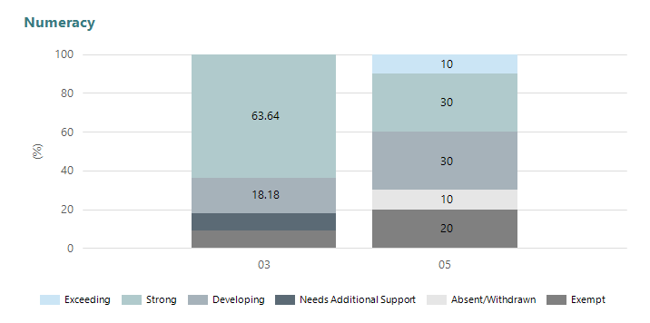
Year Level | 03 | 05
Exceeding |  | 1
Strong | 7 | 3
Developing | 2 | 3
Needs Additional Support | 1
Absent/Withdrawn |  | 1
Exempt | 1 | 2
Total | 11 | 10

Data Source: Department for Education Assessment Data Holdings, 2025. If there are less than 6 students who sat NAPLAN in a school, no information will be shown. If a year level has less than 6 students, that year level will not be shown in NAPLAN results.

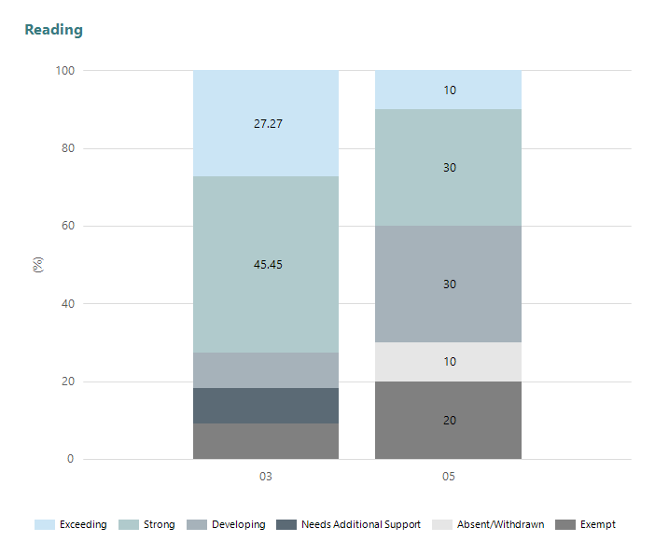
Year Level | 03 | 05
Exceeding | 3 | 1
Strong | 5 | 3
Developing | 1 | 3
Needs Additional Support | 1
Absent/Withdrawn |  | 1
Exempt | 1 | 2
Total | 11 | 10

Data Source: Department for Education Assessment Data Holdings, 2025. If there are less than 6 students who sat NAPLAN in a school, no information will be shown. If a year level has less than 6 students, that year level will not be shown in NAPLAN results.

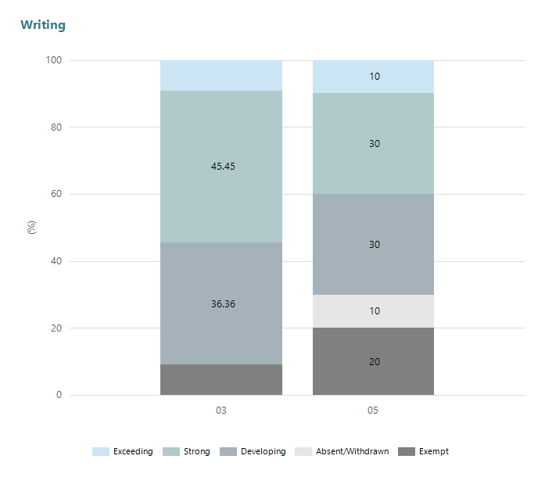
Year Level | 03 | 05
Exceeding | 1 | 1
Strong | 5 | 3
Developing | 4 | 3
Absent/Withdrawn |  | 1
Exempt | 1 | 2
Total | 11 | 10

Data Source: Department for Education Assessment Data Holdings, 2025. If there are less than 6 students who sat NAPLAN in a school, no information will be shown. If a year level has less than 6 students, that year level will not be shown in NAPLAN results.

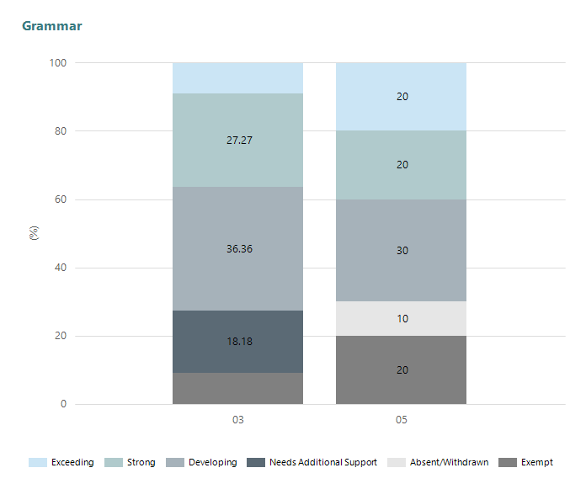
Year Level | 03 | 05
Exceeding | 1 | 2
Strong | 3 | 2
Developing | 4 | 3
Needs Additional Support | 2
Absent/Withdrawn |  | 1
Exempt | 1 | 2
Total | 11 | 10

Data Source: Department for Education Assessment Data Holdings, 2025. If there are less than 6 students who sat NAPLAN in a school, no information will be shown. If a year level has less than 6 students, that year level will not be shown in NAPLAN results.

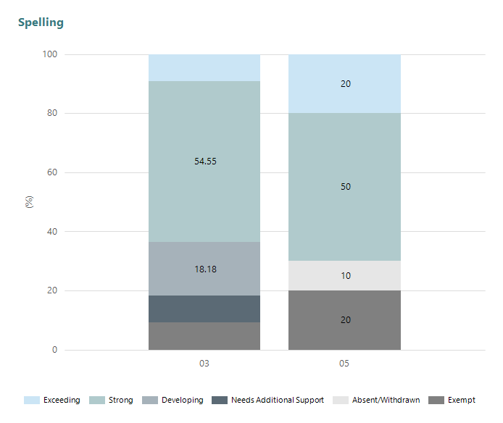
Year Level | 03 | 05
Exceeding | 1 | 2
Strong | 6 | 5
Developing | 2
Needs Additional Support | 1
Absent/Withdrawn |  | 1
Exempt | 1 | 2
Total | 11 | 10

Data Source: Department for Education Assessment Data Holdings, 2025. If there are less than 6 students who sat NAPLAN in a school, no information will be shown. If a year level has less than 6 students, that year level will not be shown in NAPLAN results.

Page Breaker

School Attendance

Year Level | 2023 | 2024 | 2025
Reception | 92.0% | 88.1% | 89.5%
Year 01 | 89.7% | 87.2% | 89.7%
Year 02 | 89.6% | 90.2% | 91.4%
Year 03 | 89.4% | 91.5% | 89.6%
Year 04 | 87.3% | 89.6% | 90.3%
Year 05 | 90.3% | 87.4% | 87.9%
Year 06 | 83.7% | 90.5% | 81.4%
Total | 88.9% | 89.2% | 88.6%

Data Source: Department for Education Attendance Data, Semester 1 Report 2025. A blank cell indicates there we no students enrolled. 'Primary Other' includes students enrolled in specialised education options. 'Secondary Other' includes students who have already spent a year at Year 12 and elected to undertake further study at Year 12.

Attendance Comment

In South Australia, all children and young people must be in school from 6 years to 16 years old. They must attend a government or non-government school full time. From age 16 to 17 however, young people must attend school or an approved learning program (such as an apprenticeship, traineeship, accredited course or university). Schools and parents must encourage and support students to come to school every day. Parents and caregivers must make sure their child is enrolled in a school, and attends school all day and everyday it is open, unless a child is sick or has an approved exemption. Teachers and leaders actively follow up when a student misses school, including recording all absences and non-attendance. All schools in South Australia have local attendance procedures governed under the Education and Children's Services Regulations 2020.

School Parent Opinion Survey Results

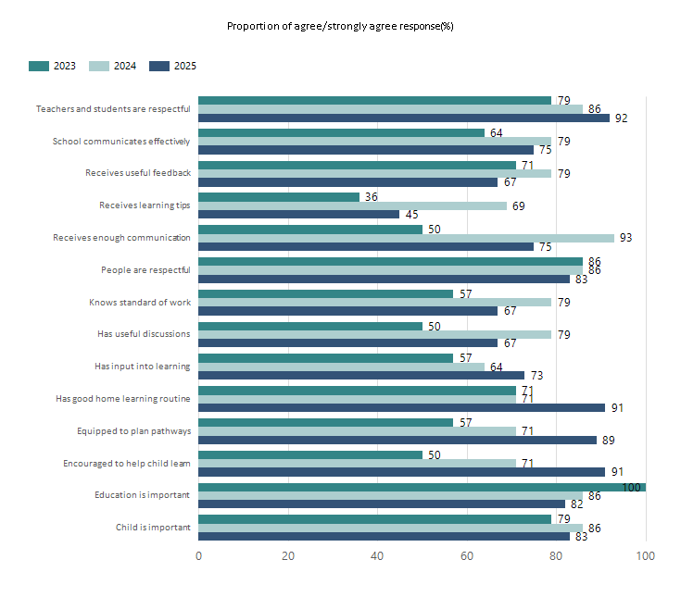
Data Source: 2025 Department for Education Parent Opinions Survey, Term 3 2025.

Page Breaker

Intended Destination

Leave Reason | Number | %
OV - LEFT SA FOR OVERSEAS | 1 | 33.0%
TG - TRANSFERRED TO SA GOVERNMENT SCHOOL | 2 | 67.0%

Data Source: Department for Education Destination Data Report, 2025. Data extract term 3 2025. Data shows recorded destinations for students that left the school in the previous year. Data is uploaded by schools in term 3 and may not reflect final or total figures at time of report creation.

Highest Qualifications held by the teaching workforce and workforce composition

All teachers at this school are qualified and registered with the SA Teachers Registration Board.

Qualification Level | Number of Qualifications
Bachelor's degrees or Diplomas | 7

Data Source: Data extracted from Mandatory Workforce Information Collections as on the last pay date of June 2025. As self-reported by staff in the system.

Please note: Data includes staff who are Actively employed and on extended paid leave. Please note only the highest qualification of the Teaching staff is reported. Excludes any number of other certifications earned.

Workforce composition including indigenous staff

 | Teaching Staff |  | Non-Teaching Staff
 | Indigenous | Non-Indigenous | Indigenous | Non-Indigenous
Full-Time Equivalents | 0.0 | 6.6 | 0.0 | 3.1
Persons | 0.0 | 7.0 | 0.0 | 4.0

Data Source: Data extracted from Mandatory Workforce Information Collection as on the last pay date of June 2025.

Please note: Data includes staff who are actively employed and on extended paid leave. "Indigenous category" is self-reported by staff in the system.

Financial Statement

Funding Source | Amount
Grants: State
Grants: Commonwealth | $7750
Parent Contributions | $24000
Fund Raising | $4970.81
Other

Data Source: School supplied data.

